Dear Parent,
Appointment for Lactation Consultancy and/or Tongue-tie assessment/treatment.
I am writing to confirm the details of your appointment as detailed in the attached email.
It is important to ensure that you will be attending at the correct practice location, details of which are included in the subject header of the accompanying email.
Please do not feed your baby for approximately 2/3 hours before your appointment time and bring the following items with you to the appointment:
- 30mls of expressed or artificial milk (frenulotomy patients only)
- A completed pre-assessment questionnaire (please print the document emailed to you, alternatively if you do not have a printer this may also be emailed back to me for printing the day before the appointment).
- Baby’s ‘red book’ and/or your postnatal notes if you are still receiving Midwifery care.
- Any feeding/Tongue-tie assessments that you may already have from other practitioners including Lactation Consultant, Tongue-tie practitioner, Health Visitor, Midwife, Breastfeeding Supporter/specialist, infant feeding team
- A breast pump if you have one
Please note
- All consultation and follow-up appointment fees are payable on the day of the consultation by cash, debit card, credit card, bank transfer, American Express.
- If you need to cancel the appointment please give 24 hours’ notice, cancellation at short notice incurs a £20 fee.
Please feel free to contact me between 8am and 7pm any day of the week if you have any questions about your baby’s treatment /care, or your appointment, all responses to telephone/text/email messages are free of charge. I very much look forward to meeting you and your baby.
Yours Sincerely,
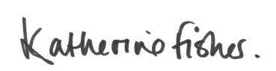
Katherine Fisher IBCLC International Board-Certified Lactation Consultant, and Tongue-tie Practitioner.

Local area map
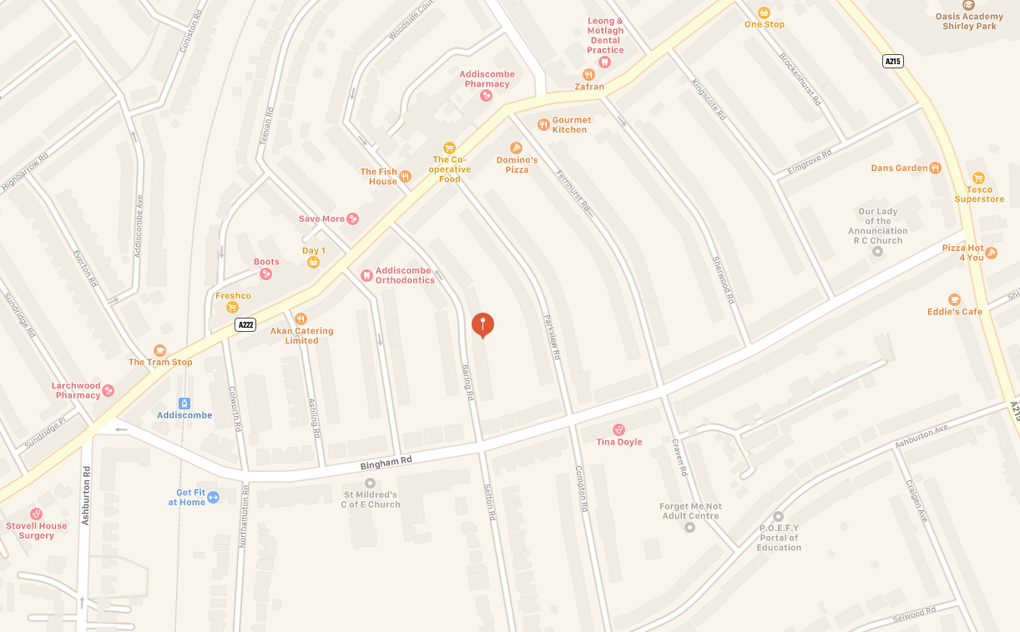

Driving
The Baring Road Practice is at 31 Baring Rd a one-way street, with entry from Bingham Road. There is usually plenty of free on street free parking.
The Dental Beauty Practice is at 69 Addiscombe Rd and is situated at the junction of Bisenden Rd ( a one way street accessed from Cedar Rd) and Addiscombe Rd, there is a free car park behind the practice in Bisenden Rd, or metered parking the same road or adjoining streets.
Train & Tram
Baring Rd Practice. The nearest British rail train station is East Croydon or West Croydon. From the Train Station, please take a tram to either Elmer’s End or Beckenham Junction to Addiscombe Tram Stop, Baring Road is just 4 streets away from Addiscombe Tram stop. Several buses stop along Lower Addiscombe Rd.
Dental Beauty Practice. East Croydon rail station and tram stop is just a few minutes walk away.
Several buses pass by the practice on Addiscombe Rd.

